

School of Systems and Technology

**Virtual System & Services Lab**

Section: Y3

**Submitted By:**

Haiqa humayun

**ID:**

F2020105110

**Submission Details:**

Lab Task: 4

Submission Date: 11 April 2023

**Submitted to:**

Instructor: Sir Asjha Khan

**Create a virtual machine and add iso file from //Punjab softwares operating system widows 7 ultimate.**

Screenshots

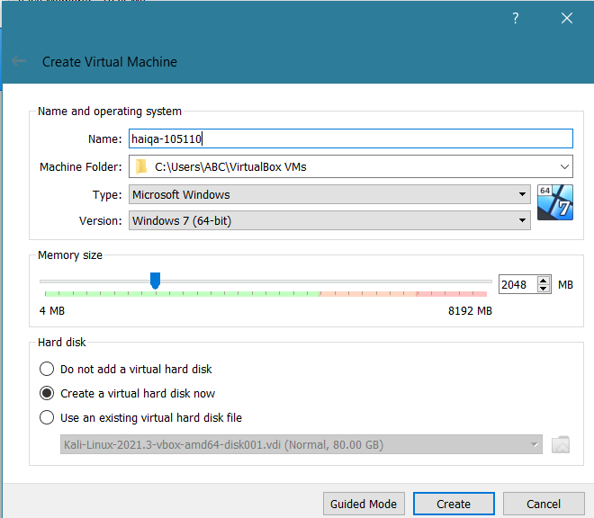

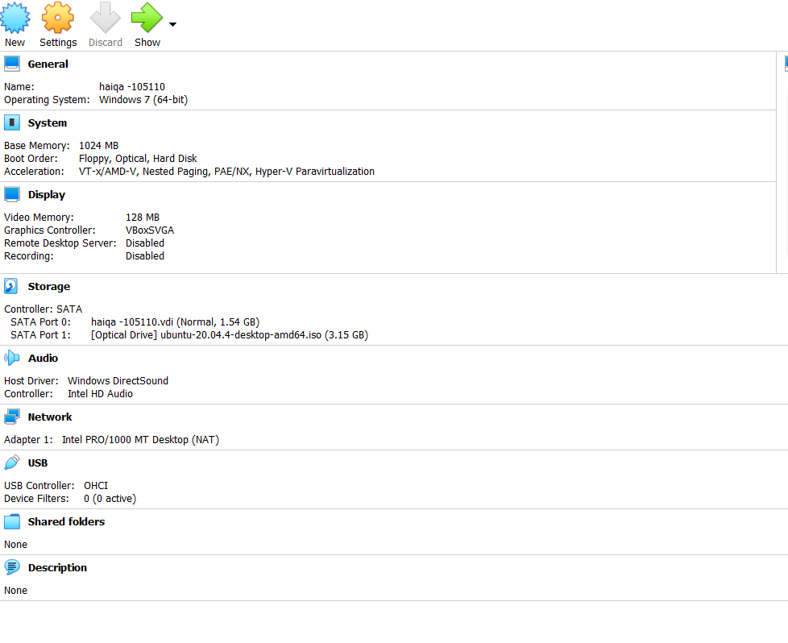

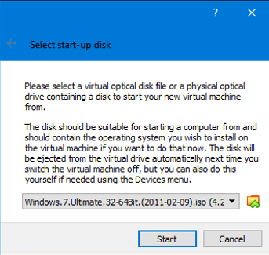

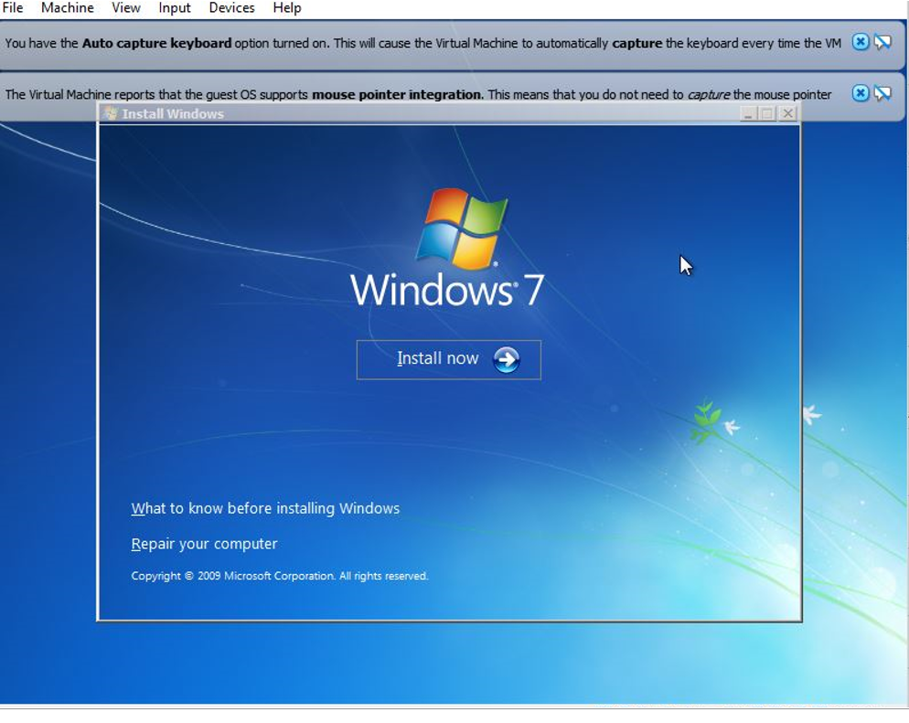

* Install window interface

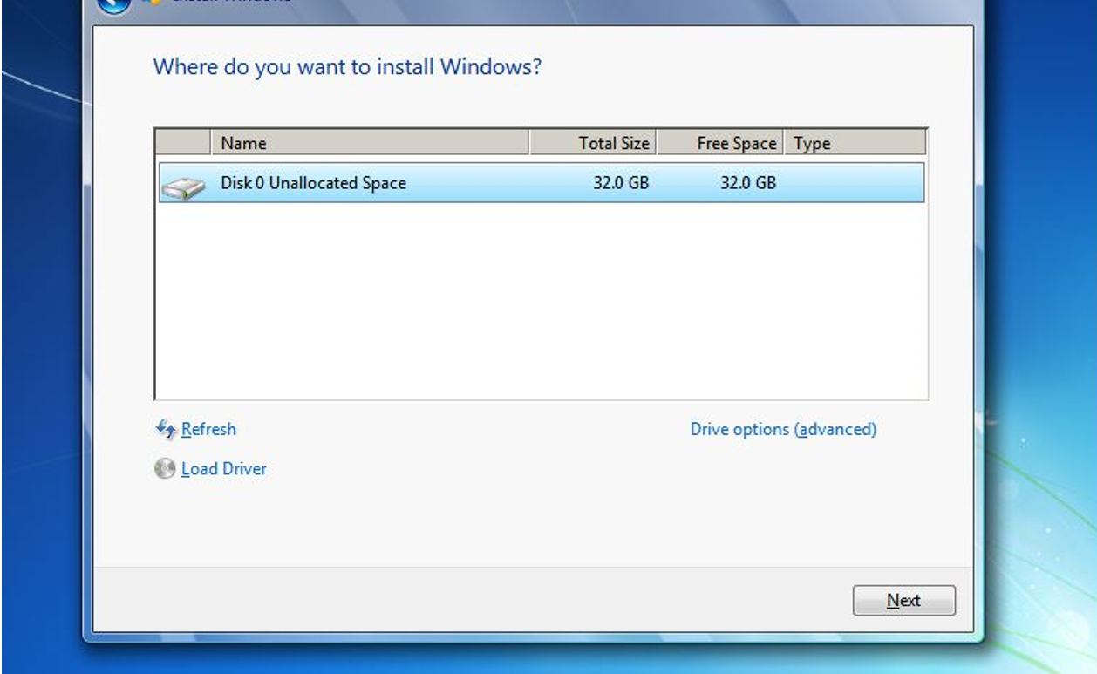

* Creating a new partition of disk partition 2 from the advance options
* Now windows is installing successfully

